\

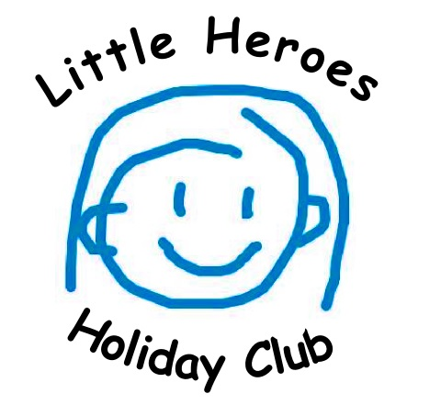 | Application Form

(This information will remain confidential, except for the purpose of an ART Inspection)
Child’s full name. First, middle name(s) and surname
Date of birth and age | /
Gender
School child attends

I would like my child to attend the following dates, from 8:30am – 3:00pm:

Religion & Ethnicity | /
Home Address
Telephone number(s) | /
Mothers name/occupation | /
Fathers name/occupation | /
Carer’s name

Email address
Person(s) who will collect child
Password for collecting child

Who to contact in an emergency
(It is imperative that these details are kept up-to-date, it is your responsibility to inform staff of any changes immediately)
Name of first person & relationship
Home telephone number
Mobile/work telephone number | M: W:

Name of second person & relationship
Home telephone number | H:
Mobile/work telephone number | M: W:

Little Heroes Holiday Club must follow the South Gloucestershire Child Protection Procedures
(A copy of which is available for parents to see upon request)

Child’s family (please advise us of family situation and who child lives with– it helps us when the child talks about family life e.g. siblings, step siblings, pets etc)

Does your child have any specific medical requirements, including allergies? | YES/NO (if yes please give details)
Does your child have any specific dietary requirements? | YES/NO (if yes, please give details
Has your child ever been excluded from a scheme similar to ours? | YES/NO
Do you give your permission for us to administer first aid to your child if necessary? | YES/NO
Do you consent for us to provide sun cream for your child to apply in hot conditions? | YES/NO
Do you give permission for your child(ren)’s photograph to be used on our website and/or facebook page? | YES/NO
Do you give consent for us to take your child off site on outings and walks? | YES/NO

Please complete and sign to accept the following declarations

I understand that the fee of £30 per day is payable in full in advance and that my child(ren) will not be accepted into the scheme unless payment has been made.

I enclose £15 one off application fee (not applicable to children who currently attend Frenchay pre-school) BACS – sort code 52-10-07 account number 90087720

I understand that if my child fails to attend a session which he or she is booked to attend, Little Heroes are unable to offer alternative sessions or issue refunds.

Signed: ___________________________ Print name: ………………………………………………….

Date: ……………………………………………….

Please hand in this form to a member of staff along with £15 cash or return via email to either: managerfrenchay@outlook.com or deputyfrenchay1@outlook.com The £15 fee can be paid via BAC’s transfer (details above).
Tel: 07982191158
This will reserve your child’s holiday club place.

