\

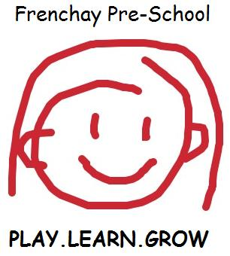 | Application Form

(This information will remain confidential, except for the purpose of a Social Services Inspection)
Child’s full name. First, middle name/s & surname
Date of birth
Gender
Religion and ethnicity
Date you would like your child to start

 | I would like my child to attend the following sessions (please tick)
 |  | Mon | Tues | Wed | Thurs | Fri
AM (9am-12pm)
PM (12pm-3pm)
FULL DAY (9am-3pm)

Home Address and postcode
Main contact name and telephone number
Mothers name/occupation | /
Fathers name/occupation | /
Email address
Main Contacts DOB
National Insurance Number

Person/s who will collect child

Who to contact in an emergency
(It is imperative that these details are kept up-to-date, it is your responsibility to inform staff of any changes immediately)
Name of first person and relationship | /  /
Home telephone number
Mobile/work telephone number

Name of second person and relationship | /  /
Home telephone number
Mobile/work telephone number

If you will not be claiming the Nursery Education Grant through us please note the charge per hour as at 1st Jan 2022 £7

Frenchay Pre-School must follow the South Gloucestershire Child Protection Procedures
Frenchay pre-school complies with all GDPR regulations

Child’s Family
Please advise us of family situation and who child lives with– it helps us when the child talks about family life e.g. siblings, step siblings, pets etc:

 | Please Tick
 | Yes | No
Has your child attended a Health Clinic for routine check-ups?
Does your child have any special requirements?
If yes, please give details below in the additional information box
Has your child had any Infectious Illnesses?
Please list below in the additional information box
Does your child attend a dentist?
Are your child’s vaccinations up to date?
Is your child known to Childrens Services or Families Plus

Any additional information you feel we should know (diet/health/religious/cultural)

Nick name or short name:
How would you like your child to recognise their name when printed in pre-school?

Password for others to pick up your child with your consent:

Do you give consent for us to claim Early Years Pupil Premium on behalf of your child? Yes/No

Does your child have a birth mark or any marks we need to be aware of whilst we are caring for them? Yes/No

Is English the only spoken language at home? Yes/No (If no please state other languages spoken)

Has a sibling previously attended the pre-school?  If yes – their name(s): __________________ | Will your child be attending any other nursery, preschool or childminder?  If Yes please state: _________________________
How did you find out about our Pre-School?

Signed: ___________________________ Date: ________________

Please hand in this form at the pre-school along with cash or
BACS transfer– sort code 52-10--07 account number 90087720 of £30
This will reserve your child’s pre-school place and provide you school t-shirt.

On receipt of this form, you will be contacted and advised about our waiting list and to organise an induction nearer your child’s start date. Thank you.

